**COMPONENT5**

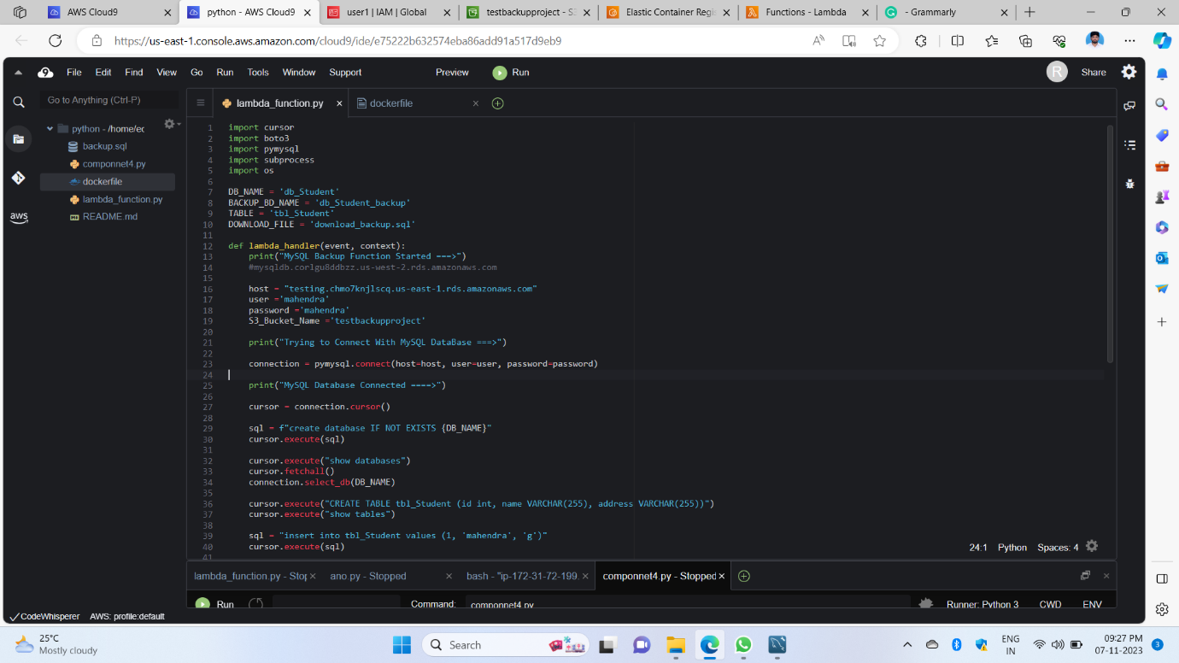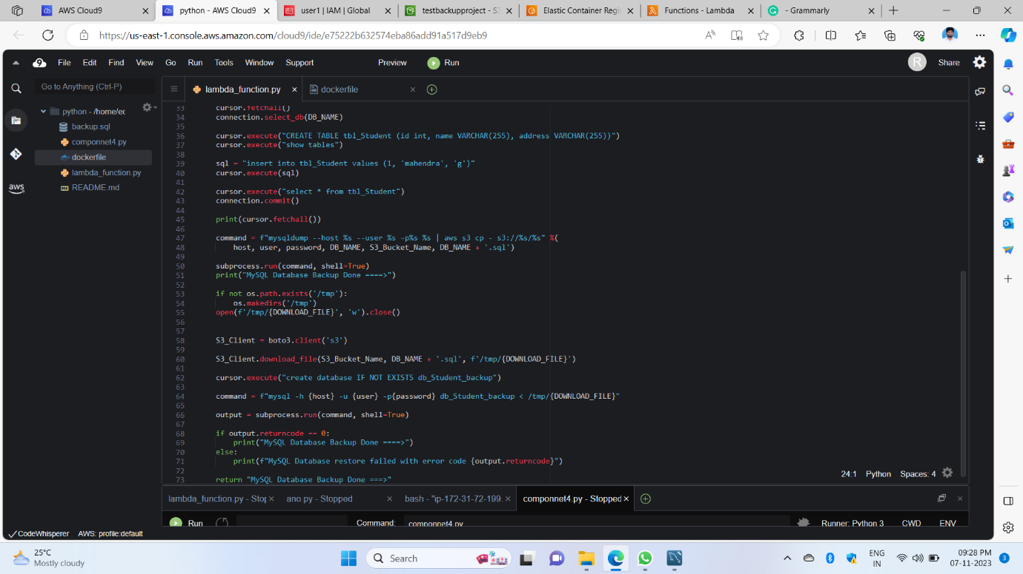

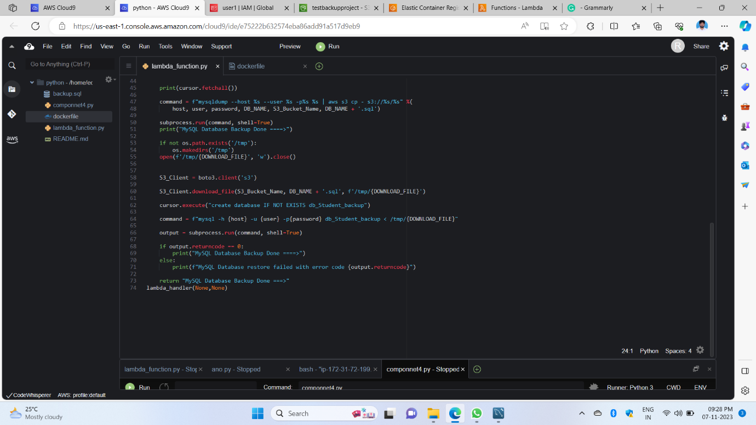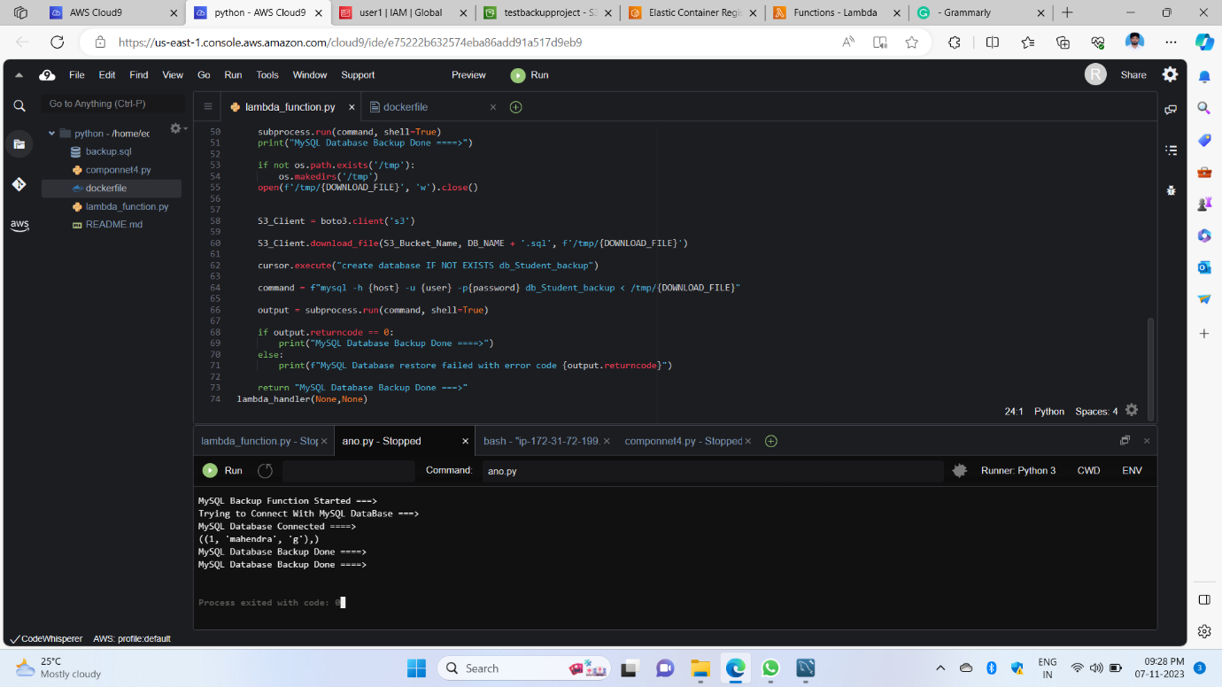

1st, 2nd, 3rd, and 4th images show this is Python code for component 5 this code helps the s3 bucket connection and RDS connection database backup and dump the backup thing with this code helping us do componnet2 to 4 this all thing combines components 5 in this we written code output showing like database connection done backup the SQL data did from s3 bucket

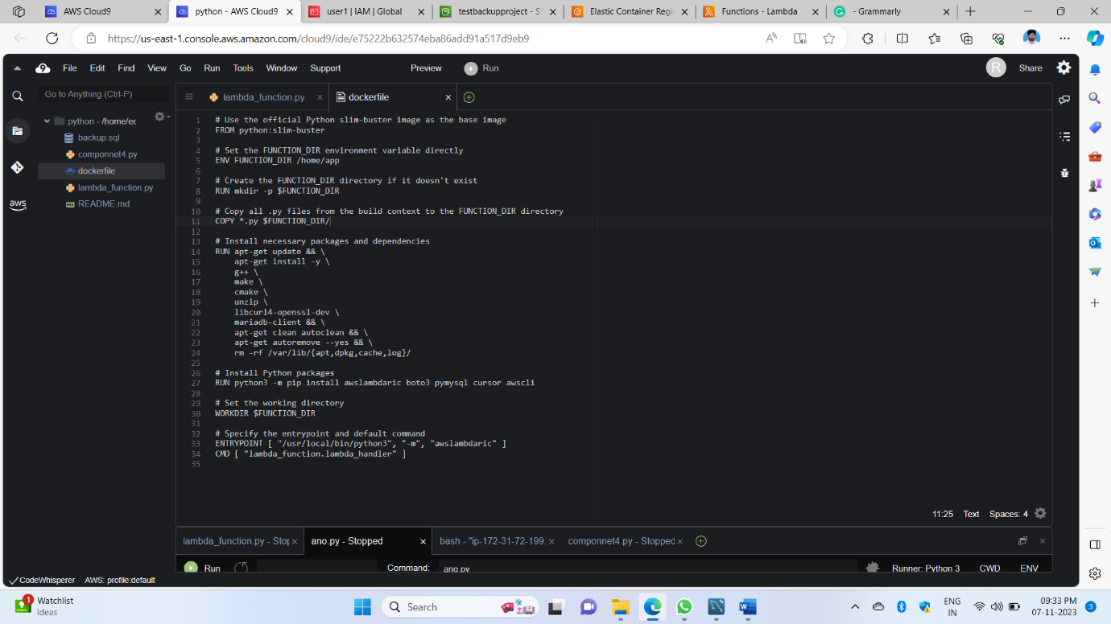

5th image shows this created docker program we can connect to the ECR service it is [**Elastic Container Registry**](https://us-east-1.console.aws.amazon.com/ecr/get-started?region=us-east-1) this is for the use of a docker connection to push objects to the ECR service for the main goal in this all python libraries can also store to push the object helps this docker file pay the role important without this not possible in another way we can create a function in lambda service in our python code we can do the zip upload but in lambda accepts its only 10MB only that why this another service we can use connect the lambda docker pays the main role

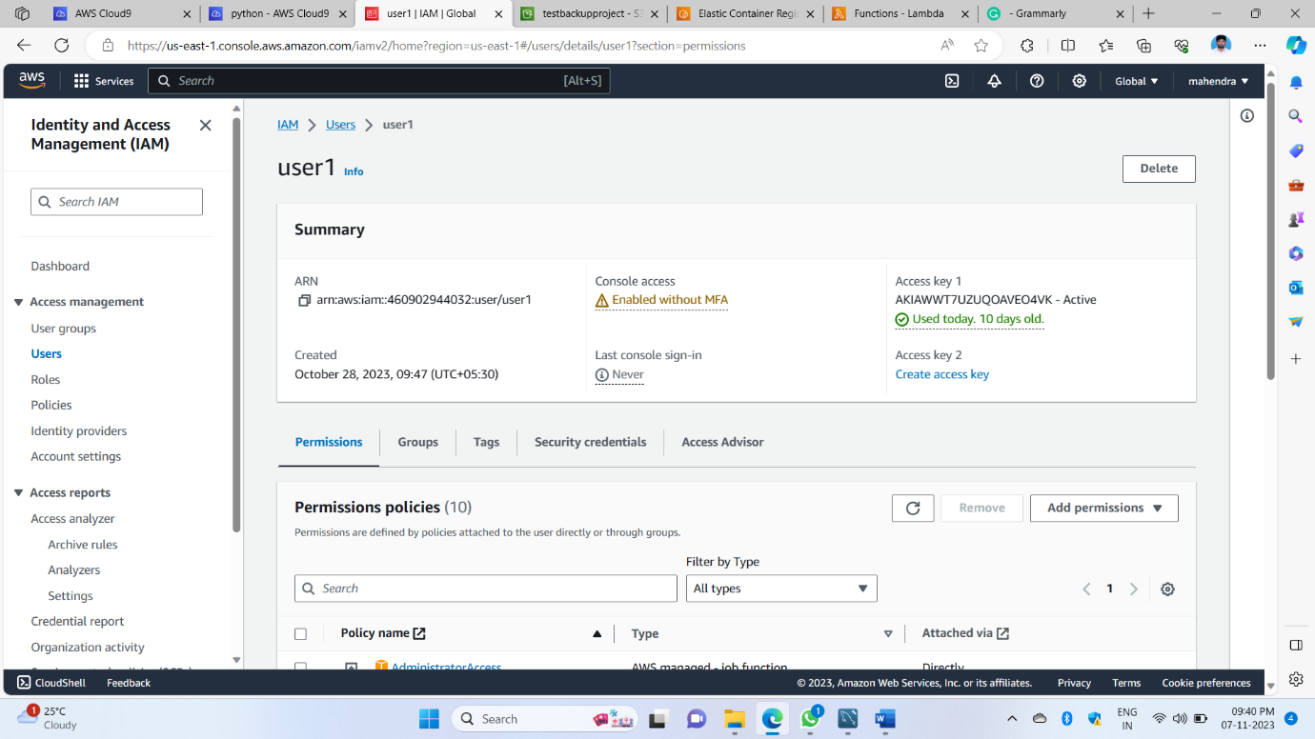

6th image is mainly we have to create an IAM user given all permission policies that are for image

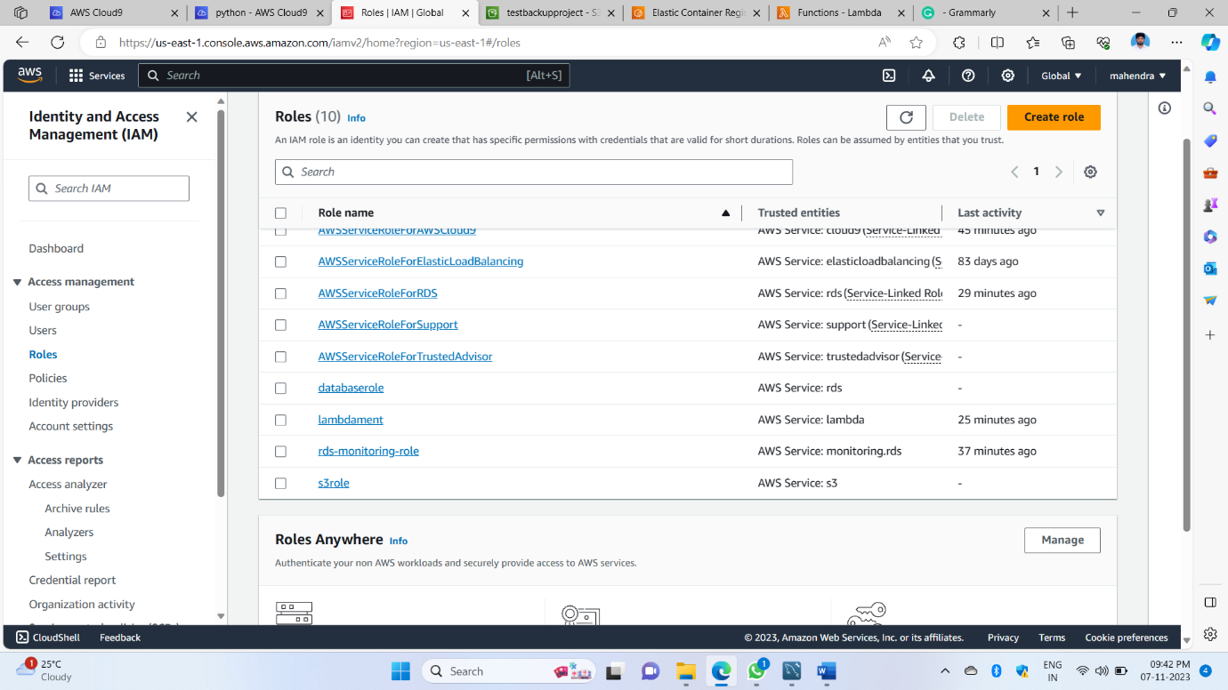

7th images showing in IAM services we have to create a role for lambda it uses in the lambda process

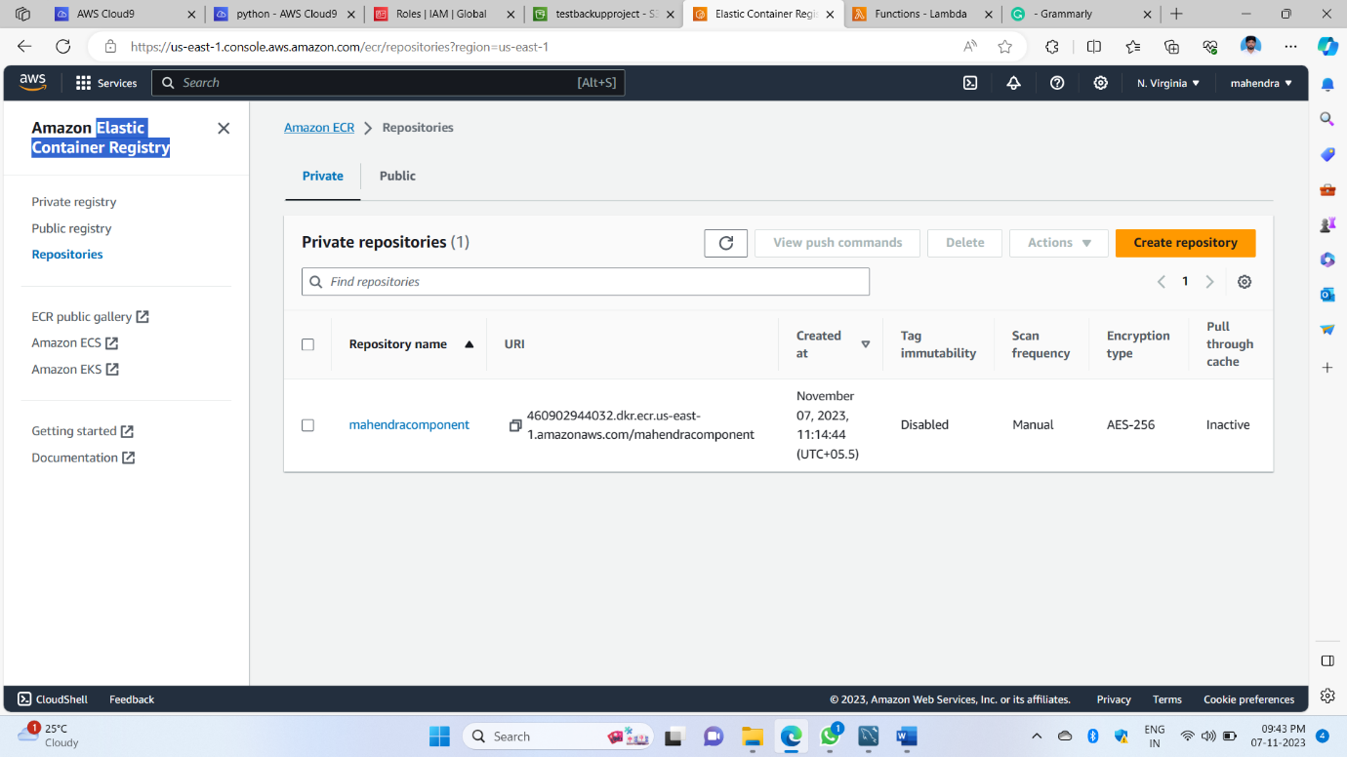 8th image showing this is a ECR service I created a repository

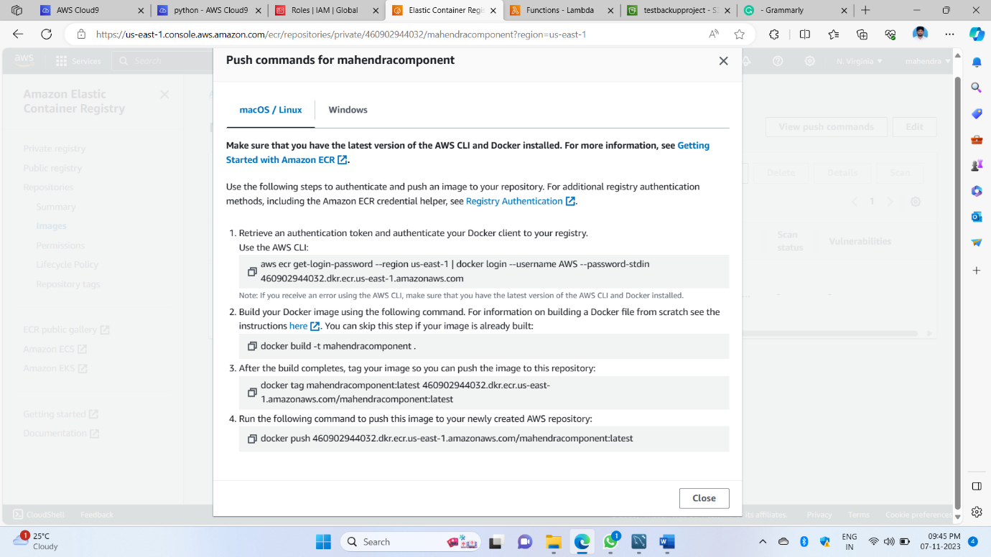

9th image shows the push command for this Python environment all this is used in this ECR service form of the image uploaded cloud 9 to ec2 all 4steps we have exquisite

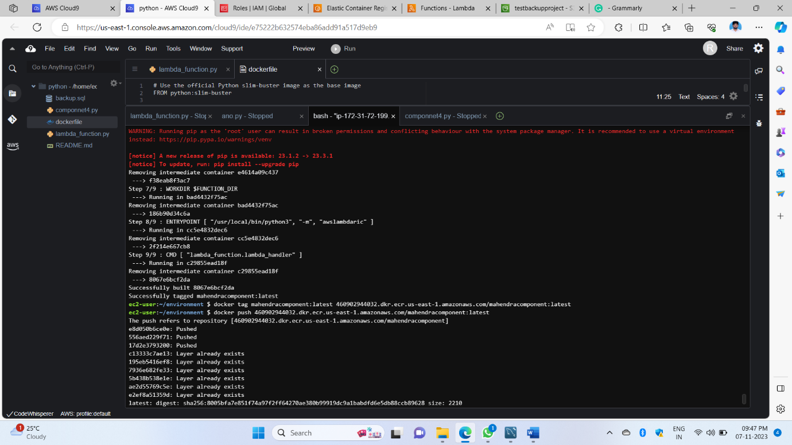

The 10th image shows that the previous 4 commands were executed in the terminal I used bash file execution of commands like this use to push all Python libraries to ECR

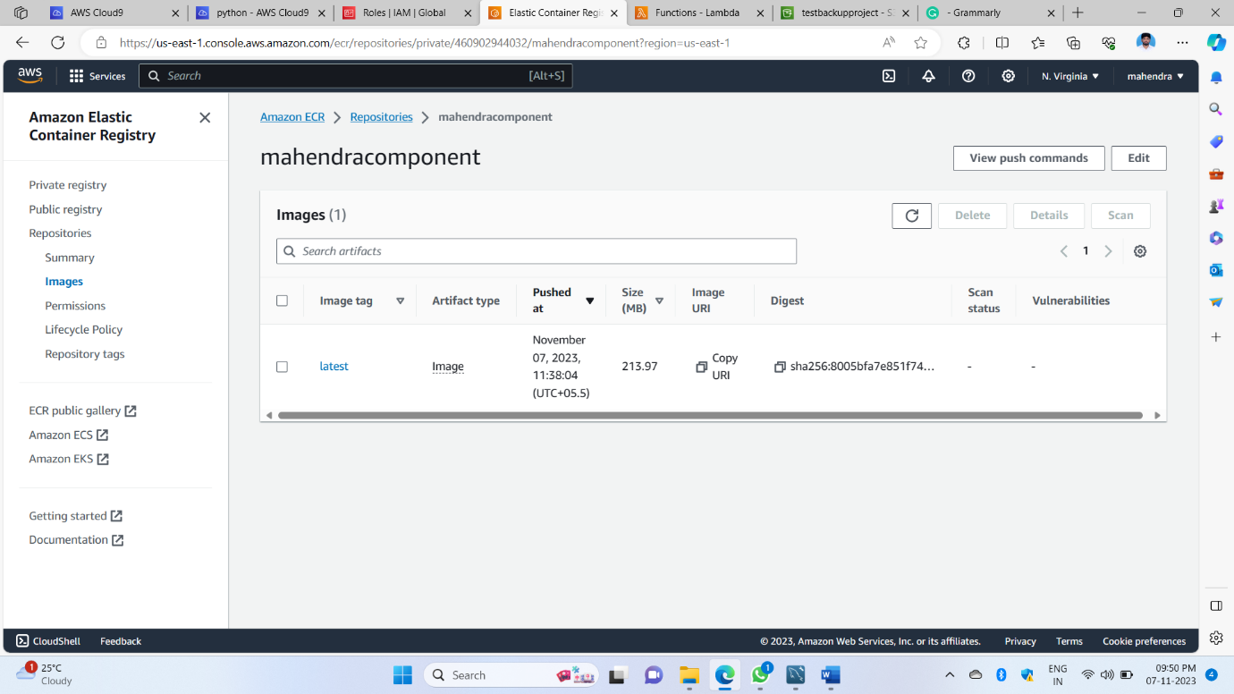

The 11th image shows pushing all Python libraries from an image-like store here

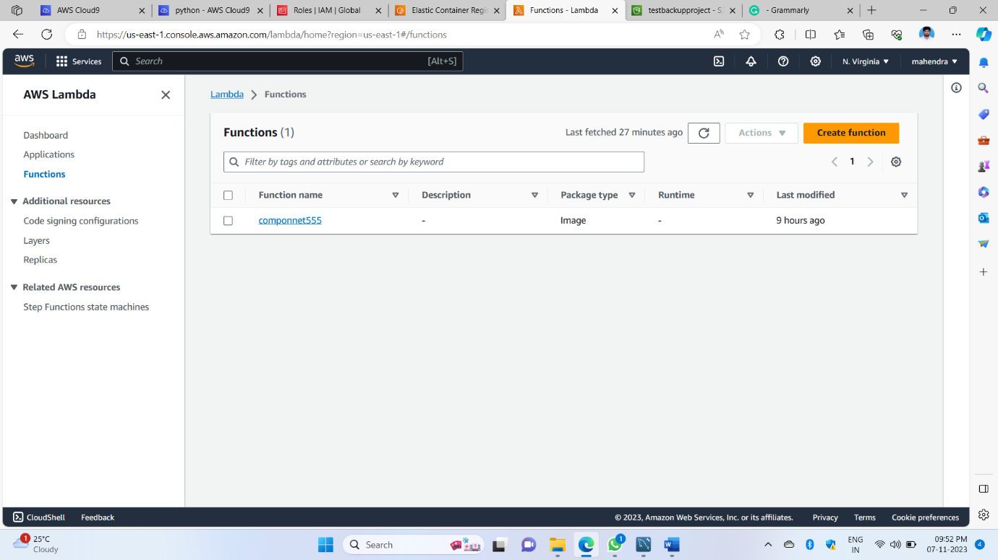

The 12th image shows here we have to create a function in the lambda service of AWS for this we have to upload ECR to function execution automatically

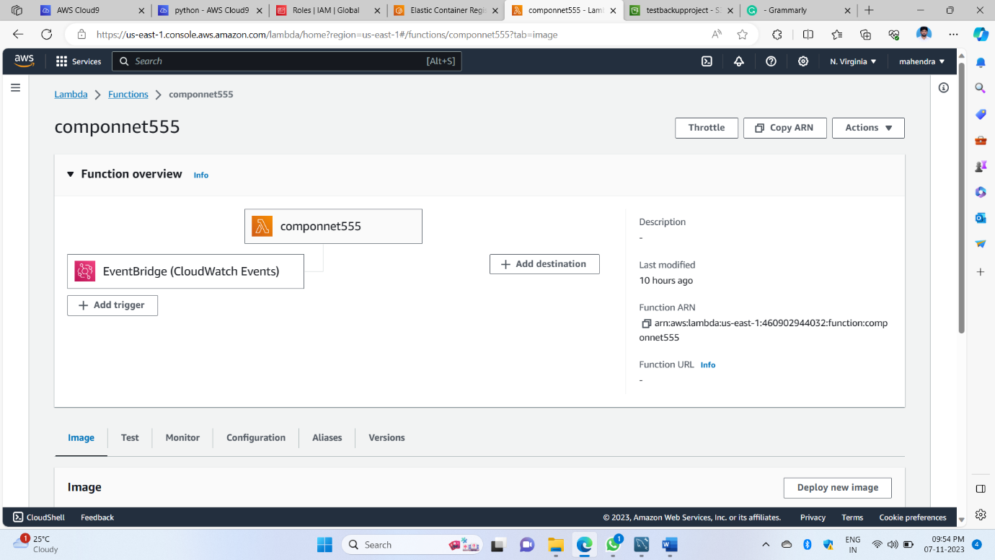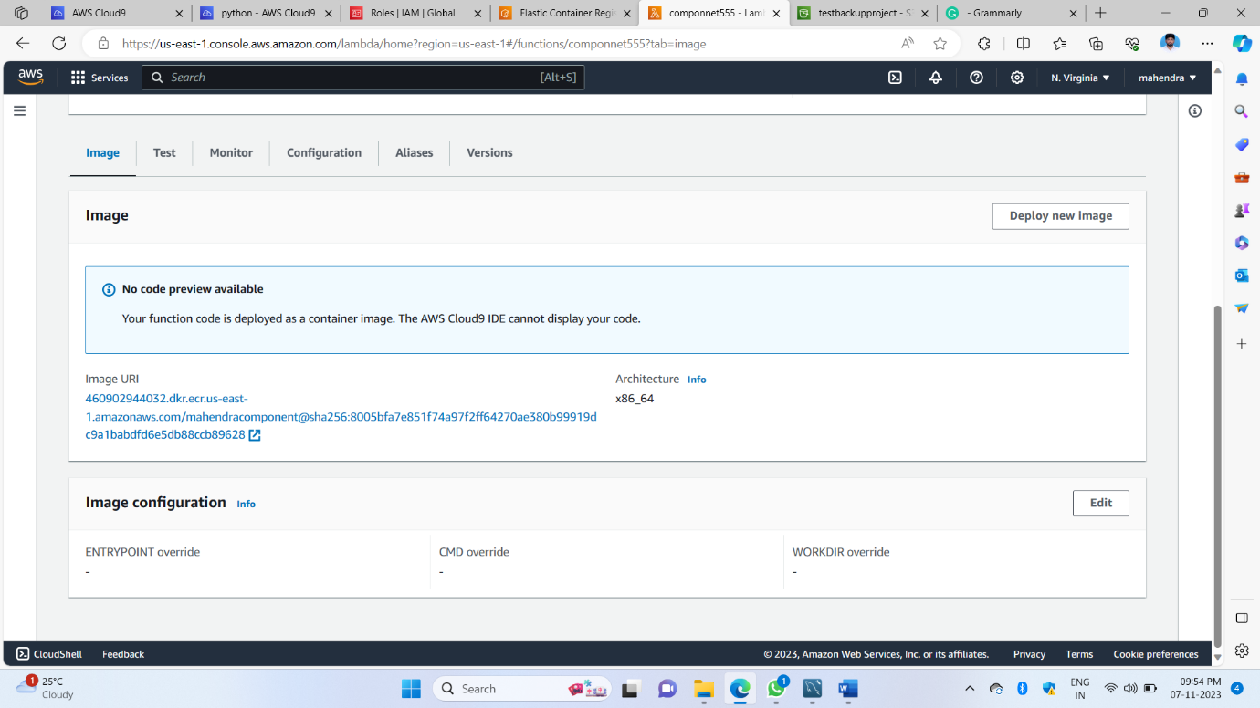The 13th and 14th images show this is inside of the function uploaded ECR image in this function and I have done configuration increases the time to 1 minute 3 seconds and we have to do the next step test to working or not

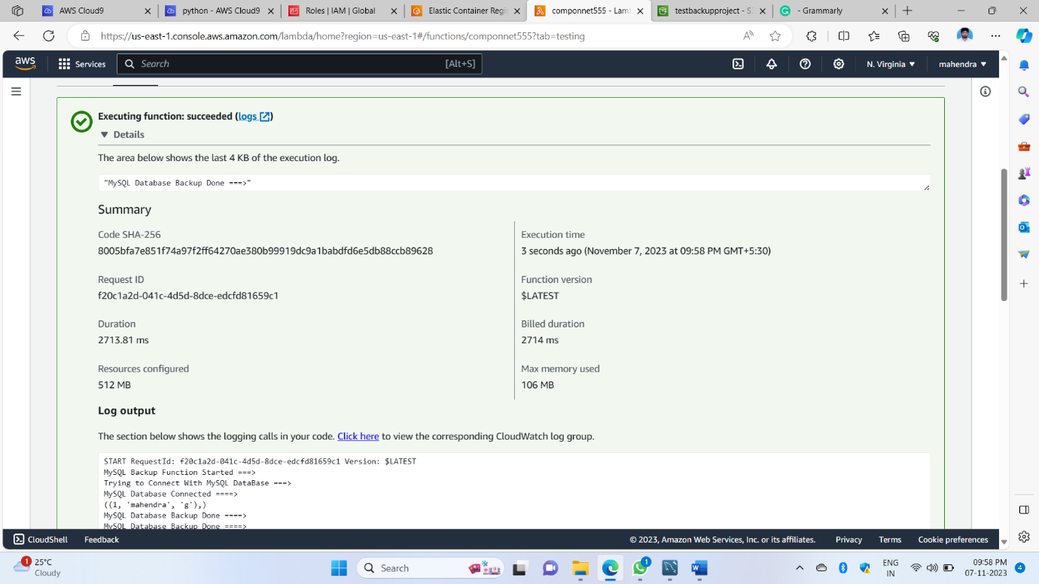

The 15th image shows the function done successful execution program runs automatically stored in this function 2 thing one is stored an object in an s3 bucket and 2nd thing is done RDS connection MYSQL connector in that store 2 file one is a backup file and another file of the student that file backup like stored this file stores the s3 entire thing done click just test button in next images shows what stores s3 and MySQL

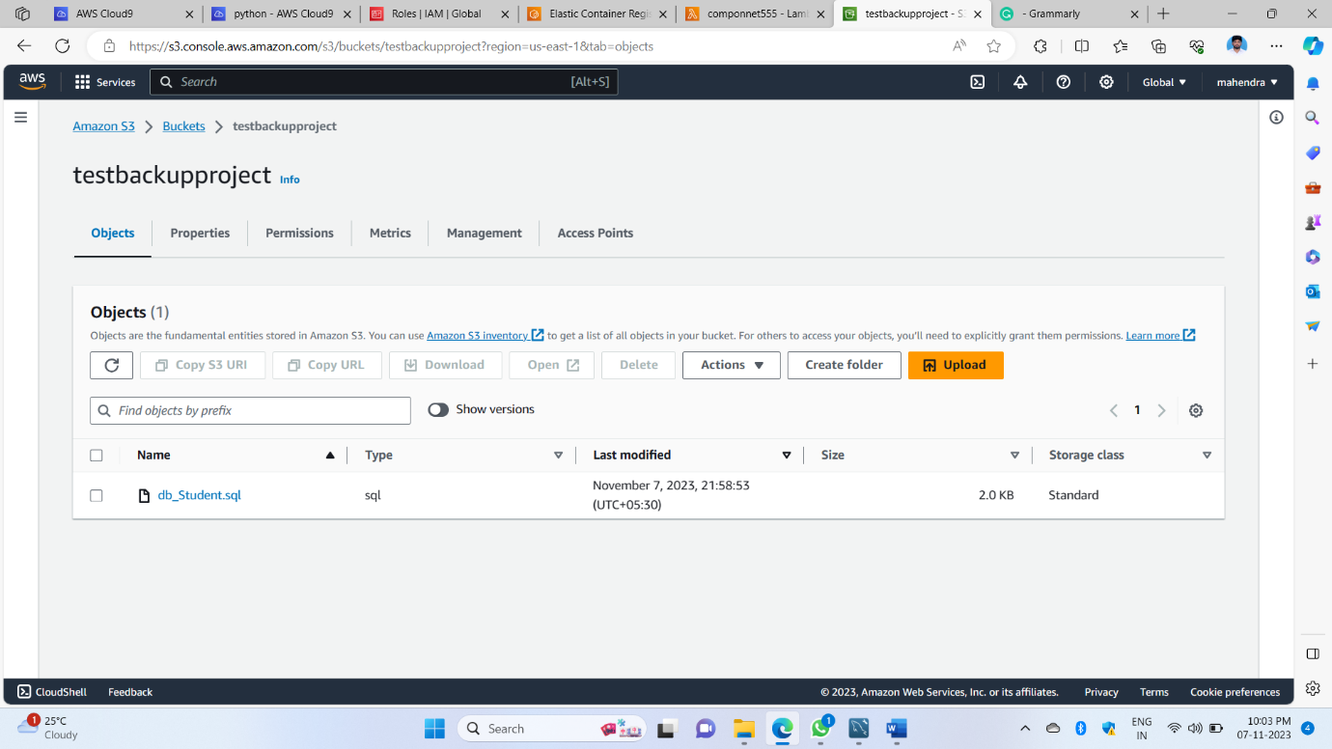 This 16th image shows the s3 bucket object stored from the function automatically

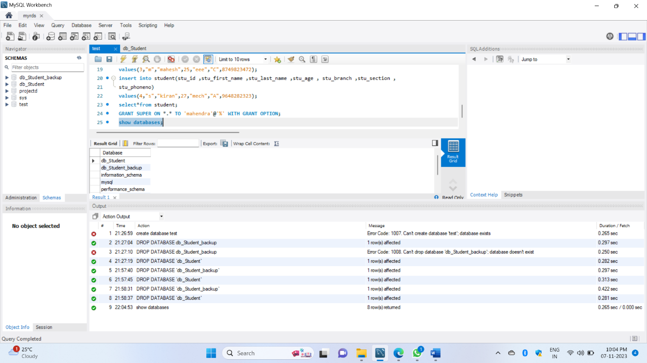

This 17th image shows the MySQL workbench stored 2 extra databases from the function automatically

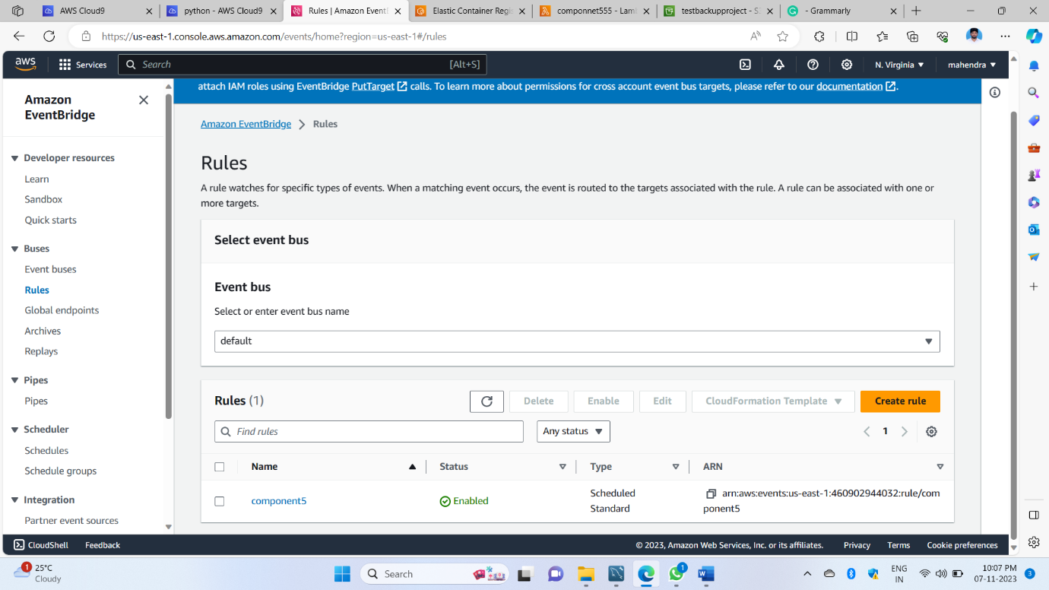

This 18th image created cloud watch for monitoring the function of the lambda service

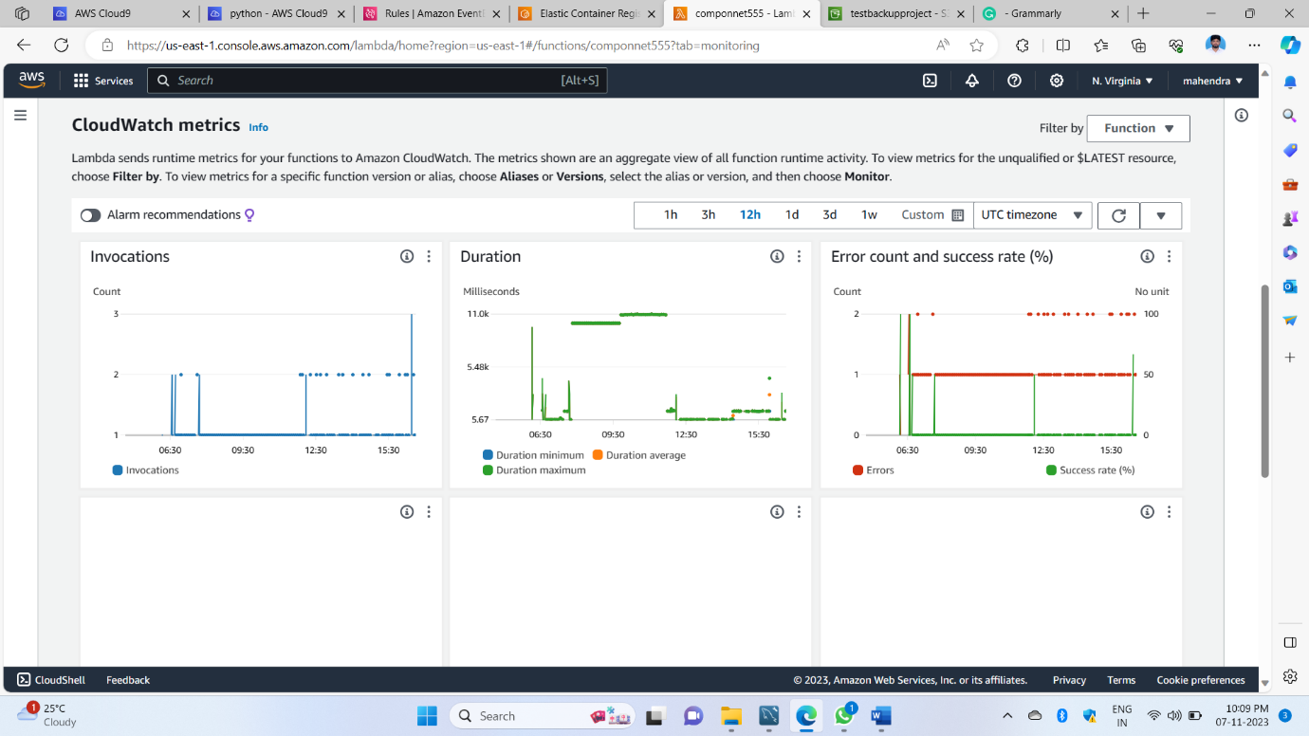

This 19th image shows the how graph using function parts working

THIS componnet5 entire thing was we have written a code and docker file ECR services and lambda function use and execution on lambda s3 and MySQL workbench connected store object uploaded and backup like restored that object our local system this anything how working like we created cloud watch connected to lambda function then we can see that working in graph

For this total project we used services like 1) S3 2) RDS 3) IAM 4) CLOUD9 5) ECR 6) LAMBDA 7) CLOUDWATCH

Outside used MYSQL workbench

All tools used and done the project